**The Chinese Columbus: Zheng He (Cheng Ho)**

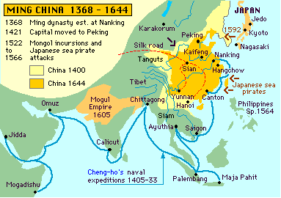

Part I. Map and Atlas Questions

Using the map above and the map of Southeast Asia in your textbook on page A32-A33, complete the following questions.

1. The Strait of Malacca, through which Zheng He sailed, lies between the southern end of the Malay Peninsula and the island of Sumatra. What two large bodies of water does this strait connect?
2. Zheng He sailed through three seas and a large bay. Name these bodies of water.
3. According to the map above, which city (cities) in Arabia did Zheng He visit? Which city in India did he visit?

# Part II. Reading Questions

Complete the following questions after reading *“Ming Dynasty Sea Voyages”*.

1. How many voyages did Zheng He make and when?
2. In 3-5 sentences, describe Zheng He’s fleet and then compare it to the fleet of Christopher Columbus.
3. What was the purpose of Zheng He’s voyages?
4. What technology did the Chinese have that Europeans lacked?

8. How has learning about Zheng He and his voyages changed your opinion about early explorers?