Date _________________
Entry # _________
The Islamic World, AD 550-1750
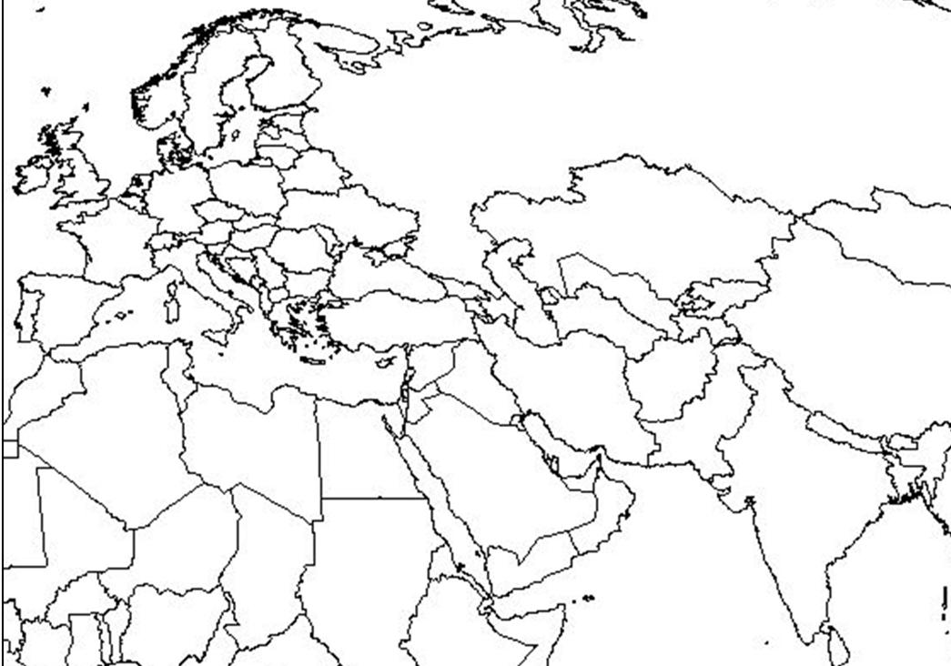
Throughout our study of the Spread of Islam, we will reference and add to our map. You will need to use the maps on p. 106, 108, 168-169, 715, 717, and 719.
LABELING
Part I
- Color and label: Mediterranean Sea, Red Sea, Persian Gulf, Indian Ocean, Atlantic Ocean

- Label the 3 continents: Africa, Asia, and Europe

- Label the countries of Bahrain, Kuwait, Oman, Qatar, Saudi Arabia, the United Arab Emirates (UAE), and Yemen = these seven modern day countries make up Arabia (or the area of the Arabian Peninsula). Lightly shade or outline these countries in brown, signifying it is a desert area.

- Label the cities of Medina, Mecca. Once we read chapter 7, section 1 (p. 170-173) write one sentence on the map telling the significance of these two cities.

Part II
- Show the three Islamic Empires by coloring them each a different color and labeling the Empires.

- Label the cities of: Cordoba, Istanbul (Constantinople), Baghdad, Esfahan

Part III
- Show the route of the first crusade – label it.

- Show the route of one other crusade and label it.

