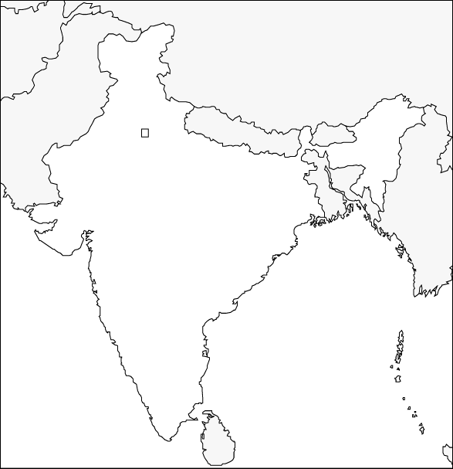

Entry # ____  **South Asia Map** Date _________

*Use pp 541 and 543 to label the following:*

* India
* Pakistan
* Nepal
* Bangladesh
* Bhutan
* Sri Lanka
* Arabian Sea
* Bay of Bengal
* Eastern and western Ghats
* Deccan Plateau
* Ganges River
* Indus River
* Brahmaputra river
* Himalaya
* Hindu Kush
* Mount Everest
* Harappa (p473)
* Mohenjo-daro (p473)