Passage of the Week (POW) in the place of AOW
This will be home work until the Reading EOG
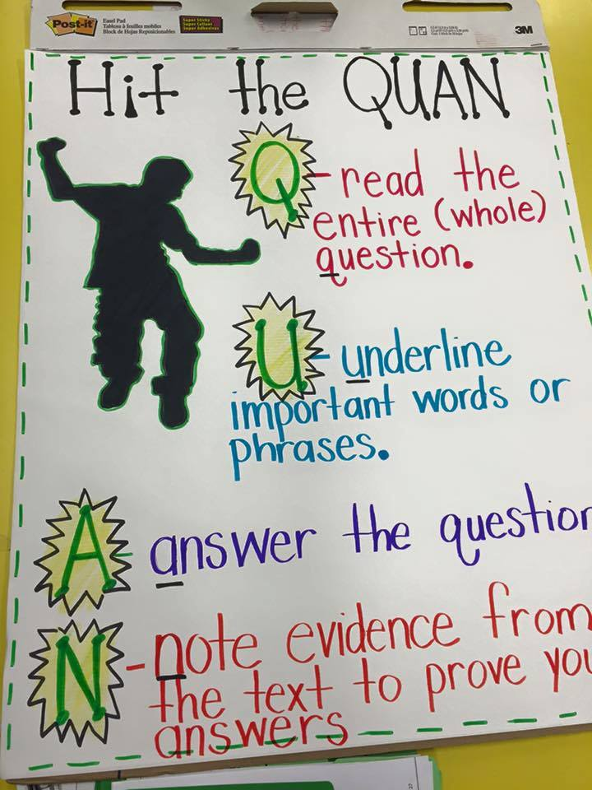
- Every week we will have a Passage of the Week (POW). It will be handed out on Monday and turned in at the end of the week (Friday).
- You must read, annotate and answer the questions.
  - Provide evidence to support your answers
  - Record your answers on the Google Form (if you do not have access to a device—arrange to come before/after school or during lunch.
- These will count as a quiz grade—I will drop the lowest one. There are 7 POWs
What else can you do?
- READ- you should ALWAYS be reading an appropriate book
- Use MobyMax to practice skills
- Review vocabulary—use your notebook (literature lingo)
- Power Word Practice: https://www.wcpss.net/students/homework-help/success-series/ms-language-arts.html
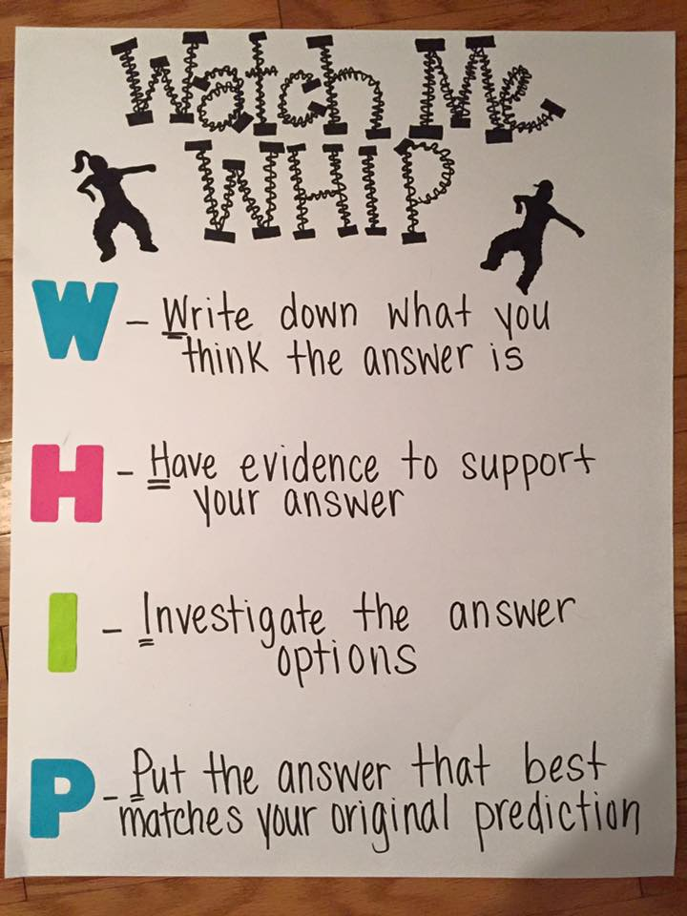
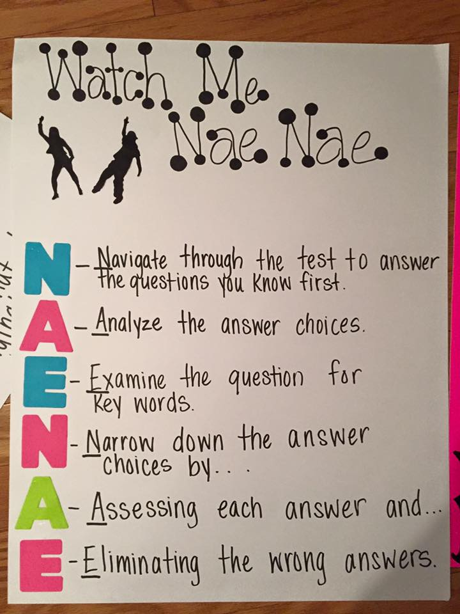

Text Annotating Symbols:
- This confirms what I already knew.
! Wow! This is an interesting fact/idea.
- I want more information about this.
- This is confusing and unclear to me.
∗ This is a new idea or word to me.
You should use words and symbols to help you interact and connect with the text!
Use a pencil

