Moon to Blame for Titanic Sinking, Scientists Say

March 6, 2012
Also on This Site
Other Current Events

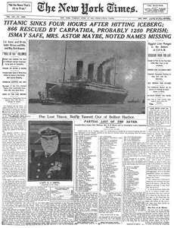
Scientists think that Earth's Moon could have played a role in the sinking of the Titanic.
In a report to be published in the April edition of Sky & Telescope, a team of astronomers assert that an unusually close approach by the Moon in January 1912 might have created tides high enough to have caused a higher-than-normal number of icebergs to break free from Greenland and go floating in the Atlantic Ocean.
The Titanic sank early on the morning of April 15, 1912, after hitting a large iceberg. The captain, Edward Smith, has been the target of blame for a century, mainly because he appears to have disregarded warnings about the presence of icebergs in the shipping lane. More than 1,500 people died when the Titanic sank on its maiden voyage.
The Moon, the astronomers say, was the closest to Earth in more than 1,400 years, and the close approach happened just six minutes of the full moon. Just six days earlier, in the last days of December 1911, Earth had reached its annual closest approach to the Sun. The result, the astronomers say, was likely a huge increase in tidal patterns, which could have created waves and pressure large enough to sheer large shelves of ice from Greenland and other frozen areas. The higher-than-normal tides would have increased the speed at which such large icebergs traveled as well, allowing them to reach shipping lanes at a faster-than-expected rate.
If this theory is true, then Smith, an experienced captain, could perhaps be forgiven for initially thinking that any icebergs floating in the north Atlantic would be small enough so as to be safely avoided

http://www.socialstudiesforkids.com/articles/currentevents/titanicmoon.htm

