Map, Globe, Atlas Comparison
Name: _______________________
Date: ____________ Block: ______

Map
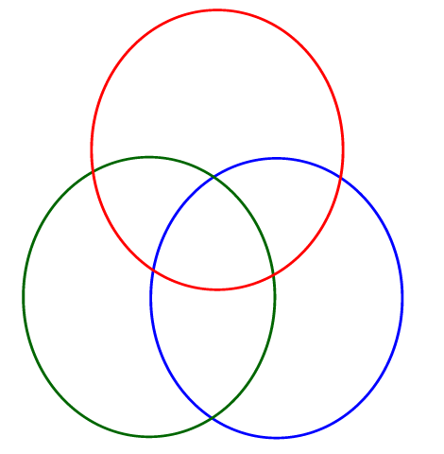
* Round (3D)
* Can spin
* Representation of the earth
* Only shows a world map
* Not mobile
* Doesn’t have detail
* Can be stood up
*Book of maps
* Has a cover
* Typed information on the side of the map
* Many different types of maps within the book
* Not in a book
* Single map
* Legend/key
* Shows land /continents
* Shows cities
* Shows oceans/bodies of water
* Mobile
* Can be of all or parts of continents, countries, or cities
* Flat (2D)
* Can show you where to go
* Can be folded up
* Single page

Globe
Atlas

