Common Core Lesson Plan

Topic: World Geography Title: Using Geographic Tools

Resources (primary resource documents, artifacts, material needs, etc.)
- Blank map of the world
- Blank globalization table
- Personal items of clothing
- Access to the internet

Common Core Standards
- WHST 1, 6
- RH 7

Essential Standards
- 6.H.1.1, 6.G.2.2

Background Information
- Students should know basic terminology such as map, chart, etc. They should also have basic geographic knowledge of the continents and oceans of the world. They may or may not have studies particular modern nations.

Instructional Sequence (before, during, and after instruction)
Step 1
The teacher will begin by Introducing the topic (geography and globalization) and pre-assessing the students’ level of content knowledge and skill.

Step 2
The teacher will distribute the resources needed to complete the tasks. This should include an explanation and overview of the blank map and of the data table template.

Step 3
The student will gather 10 items of personal clothing with the tag indicating the nation of origin.

Step 4
The student will label the blank map, indicating the countries of origin by clothing type. For example, the student may choose to all countries producing one of their shirts blue and all countries producing one of their socks red, etc. Countries with multiple items of clothing may be striped, polka dotted, whatever.

Step 5
Using their own information, students will complete the provided data sheets. They will then create a geographic representations (chart, pie chart, etc.) illustrating their results. They will then share their projects with the class, using a document camera if available.

Step 5
Students will share their maps, data, and charts with the class. The teacher should, if a document camera is available, allow students to project their maps and explain them to the class.

Step 7
Students will work in groups to create large maps and charts on butcher paper, chart paper, poster board, or other presentation materials to display on the walls of the classroom or hallway. They will then write a summary of their data and include it with their overall presentation. The summary should include a statement as to the data’s indication of the importance of middle school social studies.
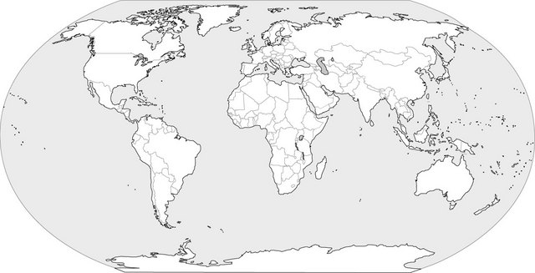

Key:

Globalization Data Table

Nation of Origin | Type of Clothing | # of Items from Nation

