Charlemagne
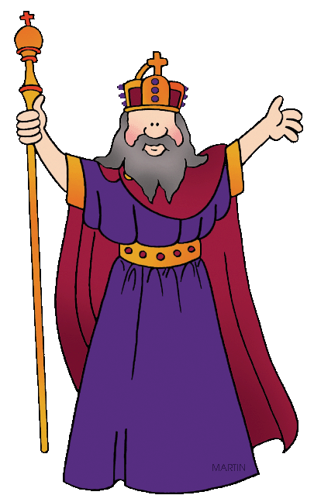

King of the Franks
Charles the Great
Holy Roman Emperor

Charlemagne was one of Europe's most successful monarchs. He was king of the Franks in 768 CE. His father, Pepin the Short, ruled before him, and his grandfather - Charles Martel - ruled before that. These two men were good rulers, but Charlemagne was a far more impressive king.
For one thing, he was very tall. He was over 6 feet tall, perhaps even as tall as 6'4". He had blonde hair that seemed to glow in the sun. He was always laughing. His dogs were his constant companions, forever racing around his feet, wherever he went. He never walked. He always strode. If you wanted to talk to Charlemagne, you had to keep up. He knew everyone in his castle by name, from his top advisors to the lowliest peasant.
As friendly as he was, Charlemagne was every inch a king. The people called him Charles the Great.
Trial by Ordeal/ Trial by Jury: One of the most important things Charlemagne did for his people was to introduce a jury system. When Charlemagne came to power as king of the Frankish Empire, he agreed that the court system was consistent, but he believed it was consistently unfair. In the Frankish court system, trial was by ordeal.
If you were a peasant and you were accused of a crime, to prove your innocence, you had to hold a red hot metal poker until your hand was deeply burned. If your burnt hand healed in three days, which it was unlikely to do, you were found innocent. If it did not, you were guilty.
If you were a noble, you could prove your innocence in ordeal by fight. You could hire someone to fight for you. If the person you hired lived, you were found innocent. If the person you hired died, you were found guilty, but you had paid your punishment - you had paid with "your" life, so to speak, or at least the life of the person you had hired - thus, you were free to go.
Charlemagne did not think much of this system of justice. He started a new system - trial by panel.
Under Charlemagne's system, each accused person would be heard by a panel of honorable men, men who had taken an oath to listen and to judge fairly based on the evidence presented. There was still corruption, but this system had a much better chance of being fair than did the old one.
Education & Preservation: One of the most important things Charlemagne did for the world was to turn his castle into a learning center - inviting scholars from all over the world to take up residence there. He used his scholars to copy the old manuscripts into Latin by hand. That preserved knowledge during the Dark Ages.
All books in the middle ages were written by hand. All books were written to glorify religion. Each page was beautifully designed. Some pages were "illuminated" with a cover of gold. These books are known as Illuminated Transcripts.

Expansion: The Franks were legendary fighters. Using the strength and loyalty of his army, combined with his own leadership abilities, Charlemagne soon defeated most of the other barbarian tribes in Western Europe. He expanded the Frankish Empire to include Germany, all of France, most of Italy, and even sections of northern Spain.
When the Frankish Empire went to war, Charlemagne was in the thick of things. He was easy to spot. Besides being so tall, he often wore a blue cape over his fur coat, which made him appear even larger. He had to have been a most visible target. Yet, somehow, he managed to survive battle after battle. He died of old age in his seventies, which for the times was a really old age.
Government: Charlemagne ruled his vast empire by using local officials called counts to help him. Each count was responsible for solving local problems. They also had the job of finding men and raising armies for the kingdom. At least once a year, Charlemagne paid surprise visits to his various counts to make sure they were managing fairly and effectively.
Standardized Money: Local administrators collected taxes from the people. The amount due was fixed. People knew how much they owed. Most taxes were paid in barter. The tax collector could decide the value of a pig or of a bale of hay. Charlemagne realized this system could easily lead to an abuse of power. He changed that system too. He introduced a payment system using silver coins. He standardized the value of each coin. It was no longer up to the tax collector to assign a pig a value. The farmer could sell his pig and then pay his taxes.
A Christian Kingdom: Charlemagne held his kingdom together by the sheer force of his personality. He was not a king in a palace somewhere. He was out and about. He heroically fought in battles, wearing his big blue cape. He personally visited local administrators, creating new laws to protect his people. He had a horrible singing voice, but he often burst into song, as he strode through village after village.
He was loud and rambunctious and brave and fair and the people adored him. He was their king and they were Franks, and proud of it. Charlemagne was able to create a Christian kingdom under a powerful secular leader - himself.

http://medievaleurope.mrdonn.org/charlemagne.html

