**Ancient Egypt Map**

Date _______________

Page # _______

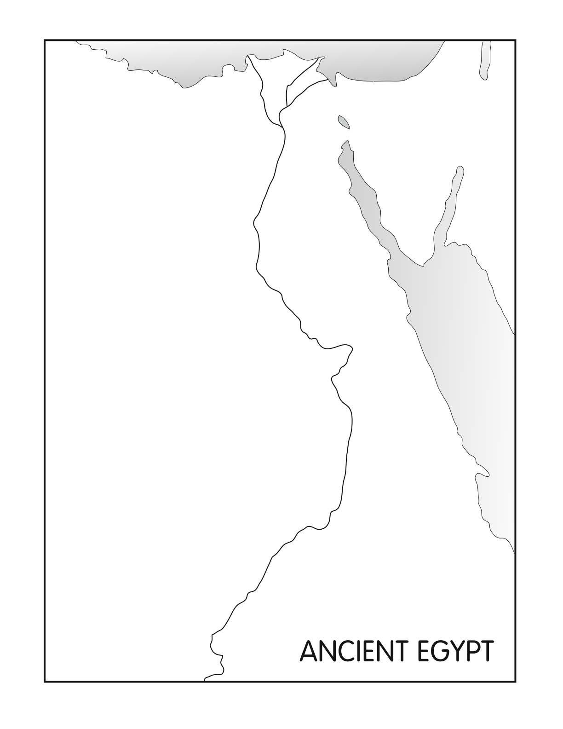

***Directions: Label the following using p69 (and 55) in your Ancient World Textbook.***

**Bodies of Water**

🞏 Nile River

🞏 Dead Sea

🞏 Mediterranean Sea

🞏 Red Sea

**Regions:**

🞏 Lower Egypt

🞏 Upper Egypt

🞏 Arabian Peninsula

🞏 Sinai Peninsula

**Ancient Cities/City-States:**

🞏 Memphis

🞏 Thebes

🞏 Giza

**Landforms**

🞏 Sahara Desert

🞏 Nile Delta

**Color**

🞏 Draw arrows showing direction of the Nile River – Green

🞏 Water – Blue

🞏 All other land - Yellow