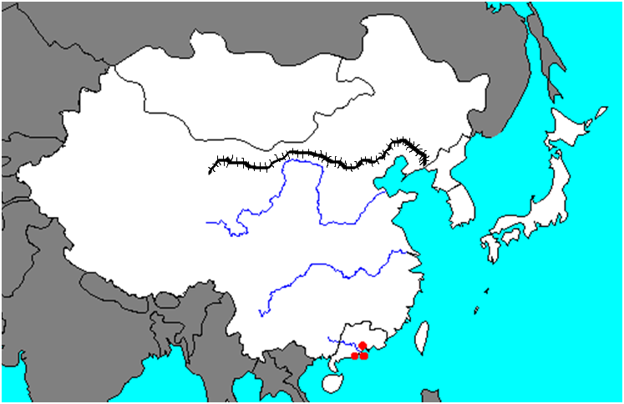

**N**

**M**

**L**

**K**

**I**

**J**

**H**

**G**

**F**

**E**

**D**

**C**

**B**

**A**

**Ancient East Asia Map Practice**

*Directions: Write the letter from the map*

*that matches the body of water, country*

*or land feature.*

_____ 1. Japan

_____ 2. Yangzi River

_____ 3. Yellow River

_____ 4. Mongolia

_____ 5. Pacific Ocean

_____ 6. Great Wall

_____ 7. Tibet

_____ 8. Yellow Sea

_____ 9. China

_____10. Taiwan

_____ 11. North Korea

_____ 12. South Korea

_____ 13. South China Sea

_____ 14. East China Sea