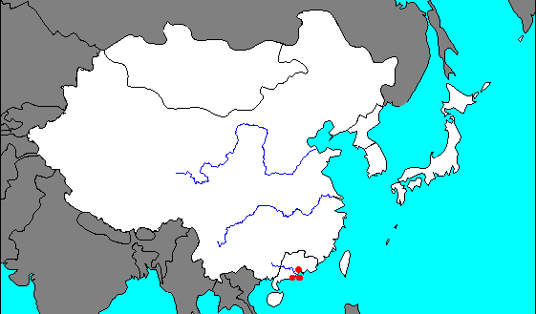

Entry # ____  **Ancient East Asia Map** Date _________

* South China Sea
* Pacific Ocean
* Great Wall of China (draw in)
* Tibet
* Japan
* Yangzi River
* Yellow River
* Yellow Sea
* East China Sea

*Use pp 565 to label the following:*

* Mongolia
* China
* Taiwan
* North and South Korea