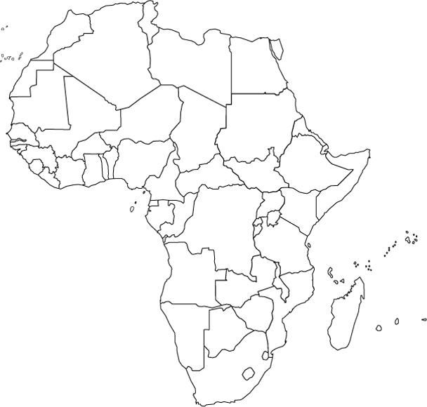
Africa Map

Label the following:
(Use Atlas p718)

Landforms
- Sahara Desert
- Mt. Kilimanjaro
- Eastern Rift Valley
- Western Rift Valley
- Serengeti Plain
- Kalahari Desert
- Nubian Desert
- Atlas Mountains

Countries
- Sudan
- Mali
- Ghana
- Democratic Republic of the Congo
- Zimbabwe
- Mozambique
- Tanzania

Bodies of Water
- Nile River
- Blue Nile
- White Nile
- Lake Victoria
- Congo River

Label the following:
(Use Atlas p718)

Landforms
- Sahara Desert
- Mt. Kilimanjaro
- Eastern Rift Valley
- Western Rift Valley
- Serengeti Plain
- Kalahari Desert
- Nubian Desert
- Atlas Mountains

Countries
- Sudan
- Mali
- Ghana
- Democratic Republic of the Congo
- Zimbabwe
- Mozambique
- Tanzania

Bodies of Water
- Nile River
- Blue Nile
- White Nile
- Lake Victoria
- Congo River

